## Lab 4

## Intruder Alarm System

Develop an application where the user opens the UI by entering a pin.

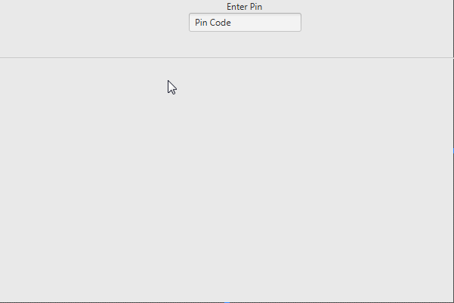

The pin should be **2018**

Once the pin is verified, you are shown the following screen

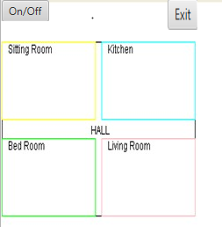

**Exit ->** Close’s the application. Add a confirm from the user to close the application!

**On/Off ->** When the system is off, the button is grey, as in the image. Once the system is on, it should look similar to below. Each room has radio buttons to enable disable the alarm. When the alarm is off, it appears as below.

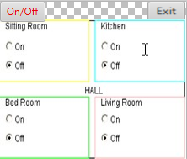

Enabling a room alarm gives the below display. A button allowing you to test the alarm!

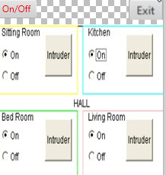

The button only appears when the alarm is on!!

Have an event occur when the button is clicked. I.e. an alarm sound or setting the background a color!

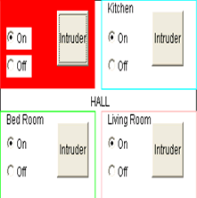

Comments are a necessity and I will be looking for them!

The design does not have to match the above hideous one so feel free to change the design but the functionality should be the same!